;l

Foundations of Programming

Assignment No: 8

PROBLEM STATEMENT:
Write a program in C to accept marks of five courses of a student and compute the result. A student is considered PASS if he/she scores 40 marks or more in each course. If the student passes, calculate the aggregate percentage and assign the grade as follows:
- Aggregate ≥ 75% : Distinction
- Aggregate ≥ 60% and < 75% : First Division
- Aggregate ≥ 50% and < 60% : Second Division
- Aggregate ≥ 40% and < 50% : Third Division

OBJECTIVE:
- To understand the use of conditional statements in C
- To apply logical operators for decision making
- To calculate total, percentage, and grade of a student
- To enhance problem-solving skills using real-life scenarios

THEORY:
In academic evaluation systems, student performance is assessed on the basis of marks obtained in individual subjects as well as the overall aggregate score. Such evaluation systems are commonly implemented in C programming using conditional statements like if, else if, and else, which allow the program to make decisions based on specific conditions.
To evaluate performance accurately, logical operators such as && (AND) and || (OR) are used to check multiple conditions simultaneously, for example, verifying whether a student has passed all subjects while also meeting aggregate criteria. The percentage calculation is carried out using basic arithmetic operations such as addition and division.

Based on the calculated percentage, grading logic is applied using predefined percentage ranges. Each range corresponds to a specific grade or class, enabling automated and consistent evaluation. This approach ensures clarity, accuracy, and fairness in result processing.
Overall, the program demonstrates the principles of structured programming by following a logical sequence of steps and effectively using decision-making constructs in C. It highlights how real-world problems, such as student result evaluation, can be efficiently solved using programming concepts.

ALGORITHM:

Start

Declare variables to store marks, total marks, percentage, grade.

Input marks of five courses from user (m1, m2, m3, m4, m5)

Check if all marks are greater than or equal to 40.

If any subject marks is less than 40 then display “Result : FAIL”

Stop the program

Cakculate TOTAL = sum of all five marks

Calculate percentage = TOTAL/ 5.0

If percentage is greater than or equal to 75 then display garde “Distinction”

Else if percentage is greater than or equal to 60 display grade “First division”

Else if percentage is greater than or equal to 50 display grade “Second division”

Else display grade “Third division”

Display Total marks, Percentage, Result, Grade.

Stop

PLATFORM: Linux
FLOWCHART:
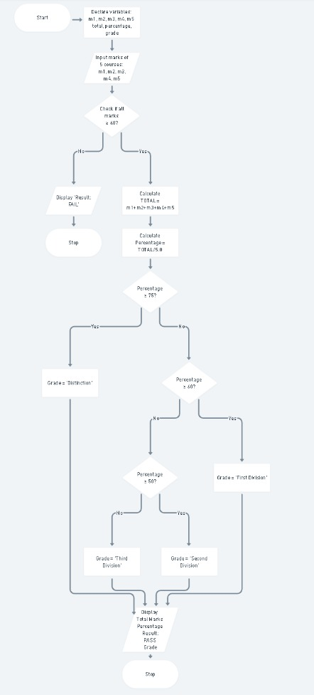

INPUT:
The user enters marks of five subjects.
Example Input:
Marks: 78 65 70 80 75

OUTPUT: The program displays the total marks, percentage, result, and grade.
Example Output:
Total Marks = 368
Percentage = 73.60%
Result: PASS
Grade: First Division

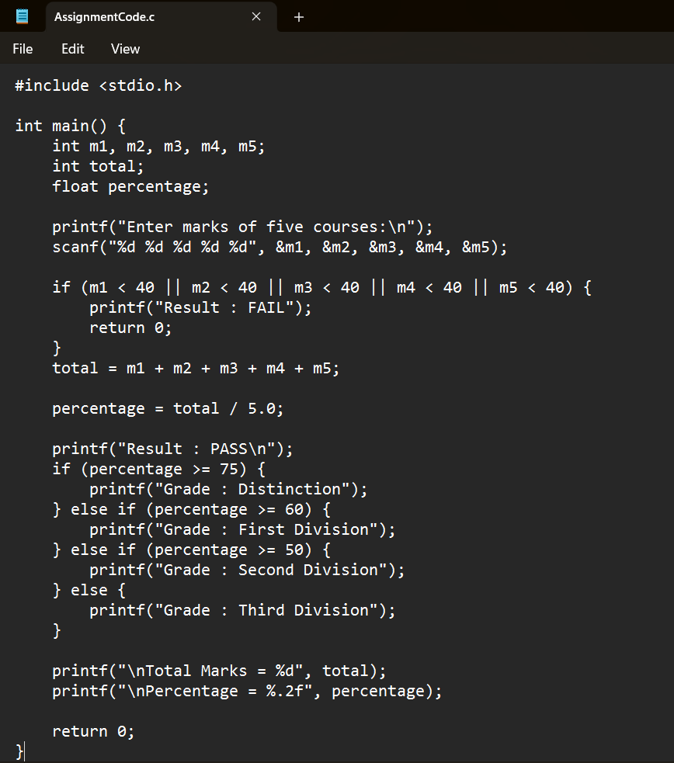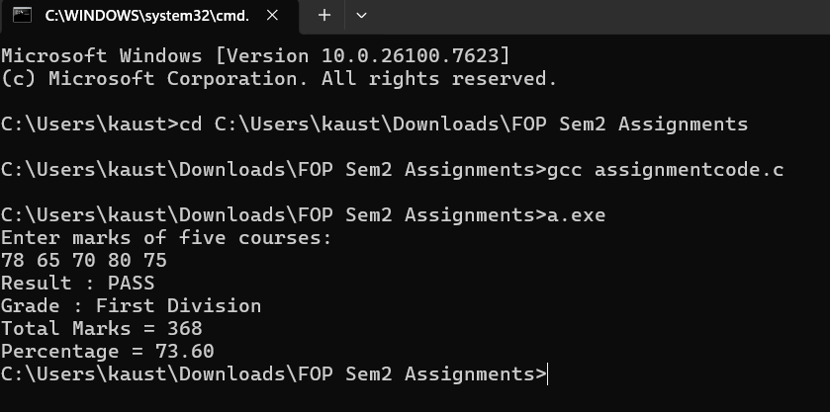
CONCLUSION: Thus, the program to calculate student result and grade based on marks was successfully implemented using C programming. This program demonstrates the effective use of conditional statements, logical operators, and arithmetic operations.

